Practical No. 1
Definition : Write a program to create and import a user-defined module
Aim/ Objective:
- To understand the concept of user-defined modules in Python.
- To learn how to create a module containing functions.
- To import a user-defined module into another Python program.
- To access and use functions defined in the imported module.

Source Code:
import mymodule

print("Addition =", mymodule.add(20, 10))
print("Subtraction =", mymodule.subtract(20, 10))

def add(a, b):
return a + b

def subtract(a, b):
return a - b

Output:
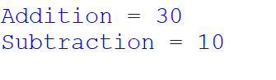

Conclusion:
Thus, a user-defined module was created and imported successfully in Python. The program helped in understanding how to organize code into reusable modules and access their functions in different programs.

Practical No. 2
Definition : Write a program to demonstrate different import mechanisms in Python.
Aim/ Objective:
- To understand different import mechanisms in Python.
- To learn the use of import, from...import, and import as statements.
- To demonstrate importing single and multiple modules in a Python program.
- To use imported modules to access functions and perform operations.

Source Code:
import math

print("1. Using import module:")
print("Square root of 25 =", math.sqrt(25))

# 2. Import a specific function
from math import factorial

print("\n2. Using from module import function:")
print("Factorial of 5 =", factorial(5))

# 3. Import multiple functions
from math import pow, ceil

print("\n3. Importing multiple functions:")
print("2 raised to 3 =", pow(2, 3))
print("Ceiling of 4.3 =", ceil(4.3))

# 4. Import module with an alias
import math as m

print("\n4. Using import with alias:")
print("Value of PI =", m.pi)

# 5. Import function with an alias
from math import sqrt as s
print("\n5. Using function with alias:")
print("Square root of 49 =", s(49))

Output:
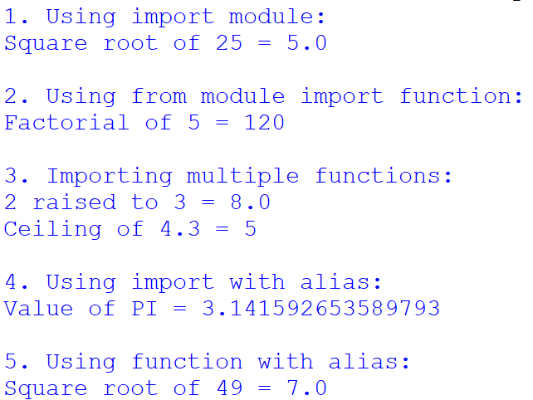

Conclusion:
Thus, different import mechanisms in Python were studied and demonstrated successfully. The program helped in understanding how to import modules and access their functions efficiently.

Practical No. 3
Definition :Write a program to perform mathematical operations using math module.
Aim/ Objective:
- To understand the use of the math module in Python.
- To perform mathematical operations using built-in functions of the math module.
- To calculate square roots, powers, factorials, and other mathematical values.
- To learn how to import and use mathematical functions in Python programs.

Source Code:
import math

num = float(input("Enter a number: "))

# Mathematical operations
print("Square root =", math.sqrt(num))
print("Power (number^2) =", math.pow(num, 2))
print("Ceiling value =", math.ceil(num))
print("Floor value =", math.floor(num))
print("Absolute value =", math.fabs(num))
print("Factorial =", math.factorial(int(num)))

# Trigonometric operations
angle = float(input("Enter angle in degrees: "))
radian = math.radians(angle)
print("Sine =", math.sin(radian))
print("Cosine =", math.cos(radian))
print("Tangent =", math.tan(radian))

Output:
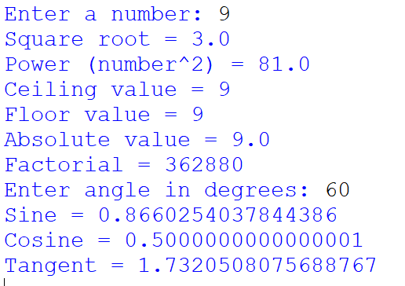
Conclusion:
Thus, the mathematical operations using Python's math module were performed successfully. The program helped in understanding and applying various mathematical functions to solve calculations easily.

Practical No. 4
Definition : Write a program to generate random numbers using random module.
Aim/ Objective:
- To understand the use of the random module in Python.
- To generate random numbers using built-in functions of the random module.
- To use functions such as random(), randint(), and randrange().
- To learn how to generate random values within a specified range.

Source Code:
import random

print("Random integer:", random.randint(1, 100))

print("Random float:", random.random())

print("Random number between 10 and 50:", random.randint(10, 50))

numbers = [10, 20, 30, 40, 50]
print("Random choice:", random.choice(numbers))

Output:
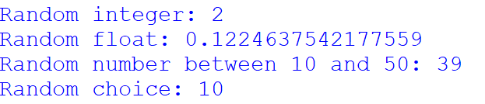

Conclusion:
Thus, random numbers were generated successfully using Python's random module. The program helped in understanding different functions used to generate random numbers and values within a specified range.

Practical No. 5
Definition : Write a program to display current date and time using datetime module.

Aim/ Objective:
- To understand the use of the datetime module in Python.
- To display the current date and time using the datetime module.
- To learn how to use the datetime.now() function to retrieve the current date and time.
- To understand how to format and display date and time in Python.

Source Code:
import datetime

# Get current date and time
now = datetime.datetime.now()

print("Current Date and Time:", now)
print("Current Date:", now.date())
print("Current Time:", now.time())

Output:
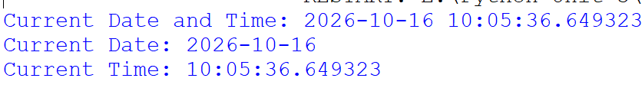

Conclusion:
Thus, the current date and time were displayed successfully using Python's datetime module. The program helped in understanding how to retrieve and display real-time date and time information.

Practical No. 6
Definition : Write a program to perform file and directory operations using os and sys modules.
Aim/ Objective:
- To understand the use of os and sys modules in Python.
- To perform file and directory operations using the os module.
- To learn how to create, rename, and remove directories and check file paths.
- To understand how the sys module provides access to system-specific parameters and functions.

Source Code:
import os
import sys
# Display current directory
print("Current Directory:", os.getcwd())
# Create a directory
if not os.path.exists("MyFolder"):
os.mkdir("MyFolder")
print("Directory created successfully.")
file_path = os.path.join("MyFolder", "sample.txt")
with open(file_path, "w") as file:
file.write("Hello, this is a sample file.")
print("File created successfully.")
if os.path.exists(file_path):
print("File exists.")

print("\nDirectory Contents:")
print(os.listdir())
print("\nPython Version:", sys.version)
print("Command-line Arguments:", sys.argv)
Output:
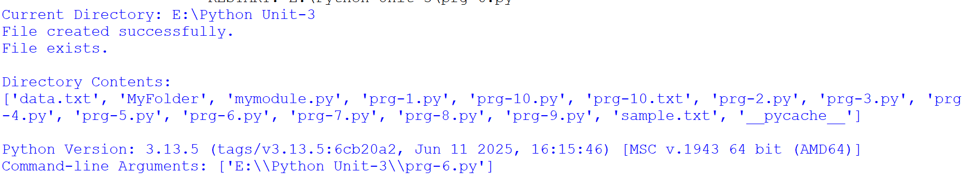

Conclusion:
Thus, file and directory operations were performed successfully using Python's os and sys modules. The program helped in understanding how to manage files, directories, and system-related information efficiently.

Practical No. 7
Definition :Write a program to copy move and delete files using shutil module.
Aim/ Objective:
- To understand the use of the shutil module in Python.
- To learn how to copy files from one location to another.
- To perform file movement and deletion operations using shutil functions.
- To understand how to manage files and directories efficiently in Python.

Source Code:
import shutil
import os

# Create a sample file
with open("sample.txt", "w") as file:
file.write("This is a sample file.")

shutil.copy("sample.txt", "copy.txt")
print("File copied successfully.")

shutil.move("copy.txt", "moved.txt")
print("File moved successfully.")
os.remove("moved.txt")
print("File deleted successfully.")

Output:
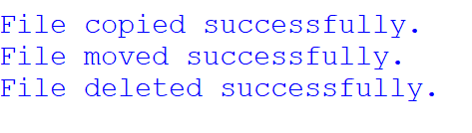

Conclusion:
Thus, file copying, moving, and deletion operations were performed successfully using Python's shutil module. The program helped in understanding how to manage files and perform file operations efficiently.

Practical No. 8
Definition : Write a program to demonstrate basic regular expression pattern matching.
Aim/ Objective:
- To understand the use of regular expressions in Python.
- To learn how to define patterns for searching and matching text.
- To demonstrate basic pattern matching using the re module.
- To identify specific characters, words, and patterns in a given string.

Source Code:
import re
text = "My phone number is 9876540123."
pattern = r"\d{10}"
result = re.search(pattern, text)
if result:
print("Pattern found:", result.group())
else:
print("Pattern not found.")

Output:
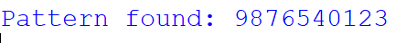

Conclusion:
Thus, basic regular expression pattern matching was demonstrated successfully using Python's re module. The program helped in understanding how regular expressions are used to search and identify specific patterns in text.

Practical No. 9
Definition : Write a program to create and import a user-defined module.
Aim/ Objective:
- To understand the concept of user-defined modules in Python.
- To learn how to create a module containing functions.
- To import a user-defined module into another Python program.
- To access and use functions defined in the imported module.

Source Code:
import re
text = "Python is easy. Python is powerful. I love Python."

# 1. match()
result1 = re.match(r"Python", text)

if result1:
print("match():", result1.group())
else:
print("match(): Pattern not found")

# 2. search()
result2 = re.search(r"powerful", text)

if result2:
print("search():", result2.group())
else:
print("search(): Pattern not found")
# 3. findall()
result3 = re.findall(r"Python", text)
print("findall():", result3)

Output:
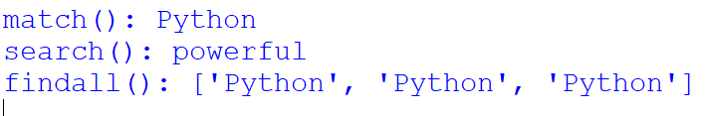

Conclusion:
Thus, a user-defined module was created and imported successfully in Python. The program helped in understanding how to organize code into reusable modules and access their functions in different programs.

Practical No. 10
Definition : Write a program to extract specific information from a text file using regular expressions.
Aim/ Objective:
- To understand the use of regular expressions for extracting information from text files.
- To read and process text files using Python.
- To use the re module to search for specific patterns such as email addresses, phone numbers, and dates.
- To extract and display the required information from a text file.

Source Code:
import re

# Open and read the text file
with open("data.txt", "r") as file:
text = file.read()

# Extract email addresses
emails = re.findall(r'[\w.-]+@[\w.-]+\.\w+', text)

# Extract 10-digit phone numbers
phones = re.findall(r'\b\d{10}\b', text)

print("Email Addresses:")
for email in emails:
print(email)

print("\nPhone Numbers:")
for phone in phones:
print(phone)

Output:
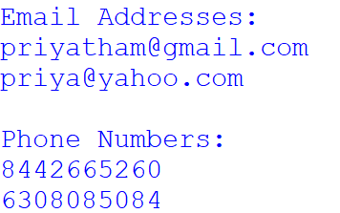

Conclusion:
Thus, specific information was extracted successfully from a text file using regular expressions in Python. The program helped in understanding how to search, identify, and retrieve required data from text files efficiently.

